OIM

Release No.: BH 1.0
Final as of: 2011/07/xx
Date: 2011/09/15
Author: Wayne R. Kehrli
Rupal Mehta
David Starke
Owner: OIM PDT
Document Name: Functional Specification
Inbound Feed from MIW
Location: OIM Teamroom

IBM Confidential
© Copyright 2011 by International Business Machines Corporation
All rights reserved.

I. This Document 3
A. Versions 3
B. Sections 3
C. Other Documents 3
D. Conventions 3
II. Document Controls 4
III. Overview 5
A. Other Documents 5
B. Screen Shots 5
C. Revisions 5
1. Original Draft 5
2. Draft 2 – updated based on change to inbound XML 5
3. Draft 3 – clarified handling Deletes 5
IV. Catcher 7
V. ABR Overview 9
A. Data Model 10
B. Mapping 10
C. REFOFER XML 11
D. REFOFERFEAT XML 13
VI. Determination of PDHDOMAIN 18
VII. User Interface 19
VIII. Subscription/Notification 19

This Document

The scope of this document is for the Inbound Feed from MIW of Reference Offerings and their Features.

Versions

Multiple versions of this document may exist. Each version has a distinct file name that ends with the date of the document.

Sections

You may use either the table of contents or the document (section) headers to locate the topic of interest.

Other Documents
- The CHW data model is documented in the Teamroom. The data model is being changed to handle Reference Offerings. There are Actions, ABRs and VEs that will need to be added/updated to support this change.
- The eAnnounce enabling technology is described in the ADD for the OIM 30b release and may be found in the Teamroom.
- BH FS ABR Data Transformation System Feed 2011mmdd.doc
- “BH FS ABR Data Transformation System Feed Mapping - … 2011mmdd.xls”
- BH FS ABR XML IDL 2011mmdd.doc

Conventions

None.

Document Controls

Document Location
This release is stored in the e-announce repository.
Ownership
Title | Responsible Party | Date
Document Coordinator(s) | Wayne Kehrli | 2011-07-18
Document Owner | OIM PDT | 2011-07-18

Revision History

Revision Number | Revision date | Summary of Changes | Changes marked
1 | 2011-07-18 | Draft 1 - initial document | N/A
2 | 2011-09-01 | Draft 2 – updated based on change to inbound XML | Yes
3 | 2011-09-15 | Draft 3 – clarified handling Deletes | Yes
This document will be reviewed within one year of the last revision or review.

Reviews
This document requires the following reviews:
Title | Role
OIM PDT | Reviewer
Approvals
This document requires the following approval:
Name | Title | Role
Mark Waitkins | PDT Lead | Approver

Distribution
This document has been distributed and made available to:
Name | Title
All members | EACM Extended PDT

Overview

The purpose of this document is to describe the Inbound System Feed from MIW and Outbound Feed of Reference Offerings in sufficient detail such that:
- the users can review and determine if it meets their requirements
- the developers can develop the application

MIW will send a XML message via MQ-Series to EACM for each Reference Offering that has been promoted. MIW will also send an XML message for each Reference Offering Feature that has been promoted along with its reference to a Reference Offering. EACM will accept the XML and place it in a new entity type within the PDH. A new ABR will be queued for each message that will perform error checking and will create or update the structure for the Reference Offering or Reference Offering Feature and its referenced Reference Offering. If there are no errors, the changed data will be queued to feed deltas to Blue Harmony via XML (ref functional specifications “BH FS ABR Data Transformation System Feed 2011mmdd.doc” and “BH FS ABR XML IDL 2011mmdd.doc”)

A report will be generated reflecting all errors and data generated.

Other Documents

N/A

Screen Shots

N/A.

Revisions

Original Draft

Draft 2 – updated based on change to inbound XML
Each Reference Offering Feature will reference exactly one Reference Offering (Machine Type Model).

Added <ACTIVITY> to inbound messages; however, only one will be supported initially by MIW. Those not supported will be defaulted to “Update”. Ref the mapping spreadsheet.

Draft 3 – clarified handling Deletes
Although the XML messages can have a “Delete” indicator for REFOFER, REFOFERREFOFERFEAT and REFOFERFEAT, only the “Delete” of the REFOFERREFOFERFEAT may be passed downstream.

Catcher

This function will exist on the CHW instance of EACM.

MIW will put messages on the following queue:
- TBD - ???

The catcher will be triggered by MQ-Series.

The function will create an instance of a new entity type MIW XML (MIWXML) defined as follows:

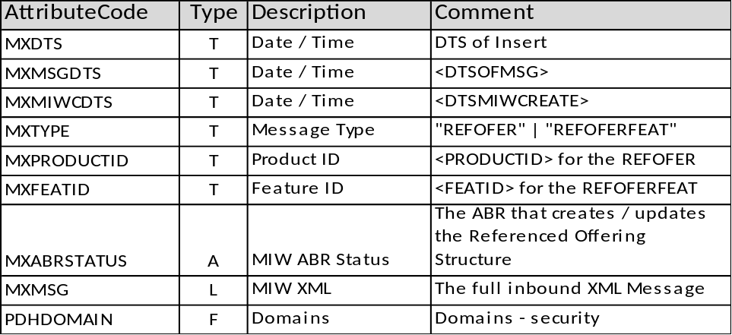

The catcher will only remove the inbound message from the queue after successfully creating an instance of this entity with the inbound XML stored in MXMSG and MXABRSTATUS set to Queued.

The Catcher will log both success and failure with an identification of the message that includes information from the message if possible:
- <DTSOFMSG>
- <DTSMIWCREATE>
- MXTYPE
- <PRODUCTID> for REFOFER
- <FEATID> for REFOFERFEAT

The Catcher will use an OP with the SYSFEEDADMIN role in the following WorkGroup:
- For CHW, use ISG
Note: the ISG Workgroup must have all of the PDHDOMAINs for which MIW inbound data will be received.
- MIW XML (MIWXML) will have a PDHDOMAIN of “ISG Setup Data” (ISG SETUP). This Workgroup and PDHDOMAIN already exists.
- REFOFER, REFOFERFEAT and REFOFERREFOFERFEAT will have a PDHDOMAIN of “MIW” (MIW). This Workgroup and PDHDOMAIN is new.

ABR Overview

There will be a new ABR that processes the instance of MIW XML (MIWXML) for which the ABR was queued. The XML to be processed is in the attribute MIW XML (MXMSG).

There are two “Message Type” (MXTYPE):
- REFOFER – adds or updates a Reference Offering.
If the Reference Offering already exists in the Product Data Hub (PDH), the ABR will update the Offering; otherwise, it will add the Reference Offering. A request to “Delete” the Reference Offering will result in an error being reported; however, the data will not be deleted from the PDH nor will it be passed downstream.
- REFOFERFEAT – adds or updates a Reference Offering Feature and/or the relationship from the Reference Offering to Reference Feature.
If the Reference Offering Feature already exists in the PDH, the ABR will update the Feature; otherwise, it will add the Reference Offering Feature. This XML also has a related Reference Offering. The ABR will update the reference (“Update” or “Delete”) in order for the PDH to match the XML. If the Reference Offering (REFOFER) does not exist, this will be reported as an error and a skeleton version of the REFOFER will be created. This skeleton version will not flow downstream until after MIW sends an “Update” (addition) for this REFOFER. A request to “Delete” the Reference Offering Feature will result in an error being reported; however, the data will not be deleted from the PDH nor will it be passed downstream.

Data Model
The database key is shown in bold pink.
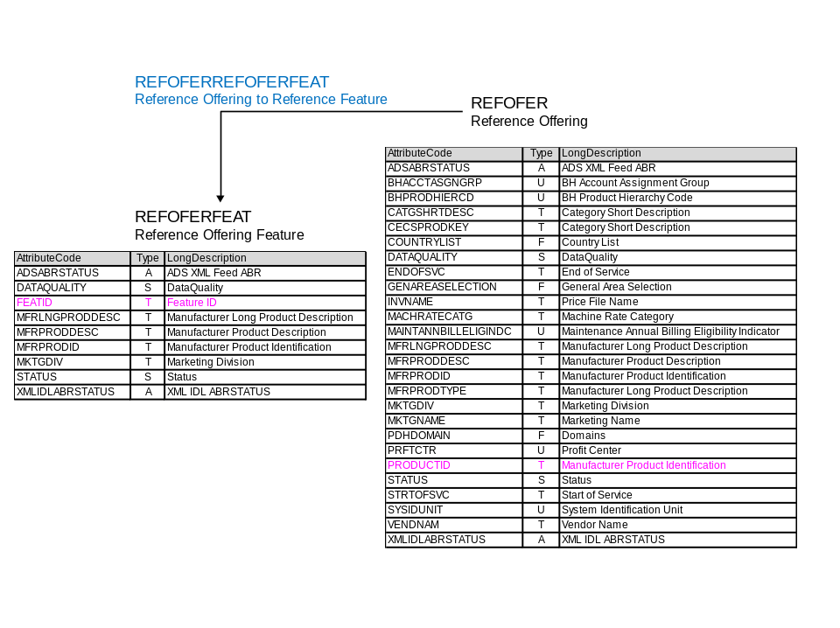

Mapping

The functional specification “BH FS ABR Data Transformation System Feed 2011mmdd.doc” has an embedded spreadsheet named “BH FS ABR Data Transformation System Feed Mapping - … 2011mmdd.xls” that provides the mapping from the XML to the EACM Data Model. There are two tabs:
- REFOFER_INBOUND
- REFOFERFEAT_INBOUND

REFOFER XML

The steps are:
- Search with PDHDOMAIN = “MIW” (MIW) for Reference Offering (REFOFER) using:
  - PRODUCTID = <PRODUCTID>

- If REFOFER
  - Found –
    - If <Activity> = “Update”, then update any attributes changed on REFOFER
    - If <Activity> = “Delete”, then set <ENDOFSVC> = LEFT(<DTSOFMSG>,10)
Note: the REFOFER will be sent downstream as if it was withdrawn since the <ENDOFSVC> is set to the last update by MIW which is in the past.
    - Report this:
Date/Time = MXMSGDTS
MIW Create = MXMIWCDTS
Message Type = MXTYPE
Product ID = MXPRODUCTID
Message = “Reference Offering was marked for Delete; however, the Reference Offering was not deleted. The End of Service was updated to match this change. This change was feed to downstream systems.”

  - Not Found –
    - If <Activity> = “Update”, then create a new instance of REFOFER and set attribute values from the XML – see the mapping in the MIWXML table.
    - If <Activity> = “Delete”, then indicate an error:
Date/Time = MXMSGDTS
MIW Create = MXMIWCDTS
Message Type = MXTYPE
Product ID = MXPRODUCTID
Message = “Reference Offering was marked for Delete; however, the Reference Offering does not exist in the PDH”

Do not proceed with any further processing of this XML message and set the ABRs attribute (MXABRSTATUS) = “Failed” (0040).

- If REFOFER was updated - Set the following attributes for the REFOFER if it was added or updated (including <Activity> = “Delete”).
  - DataQuality (DATAQUALITY) = “Final” (Final)
  - Status (STATUS) = “Final” (0020)
  - “ADS XML Feed ABR” (ADSABRSTATUS) = “Queued” (0020)
  - “MIW ABR Status” (MXABRSTATS) = “Passed” (0030)

REFOFERFEAT XML

The steps are:
- Search without PDHDOMAIN for Reference Offering Feature (REFOFERFEAT) using:
  - FEATID = <FEATID>

- If REFOFERFEAT
- Found –
  - If <ACTIVITY> = “Update”, then update any attributes changed on the REFOFERFEAT. Also, set the following attributes:
      - DataQuality (DATAQUALITY) = “Final” (Final)
      - Status (STATUS) = “Final” (0020)
      - “ADS XML Feed ABR” (ADSABRSTATUS) = “Queued” (0020)
      - “MIW ABR Status” (MXABRSTATS) = “Passed” (0030)

  - If <ACTIVITY> = “Delete”, then set STATUS = “Change Request” and indicate an error:
    - Date/Time = MXMSGDTS
    - MIW Create = MXMIWCDTS
    - Message Type = MXTYPE
    - Feature ID = MXFEATID
    - Product ID = MXPRODUCTID
    - Message = “Reference Offering Feature was marked for Delete. The STATUS was set to “Change Request”. Please review and decide how to proceed.”
    - “MIW ABR Status” (MXABRSTATS) = “Failed” (0040)
Do not proceed with any further processing of this XML message. This change is not fed downstream.
- Not Found –
  - If <ACTIVITY> = “Update”, then create a new instance of REFOFERFEAT and Set attributes from the XML – see the mapping in the MIWXML table. Also, set the following attributes:
      - DataQuality (DATAQUALITY) = “Final” (Final)
      - Status (STATUS) = “Final” (0020)
      - “ADS XML Feed ABR” (ADSABRSTATUS) = “Queued” (0020)
      - “MIW ABR Status” (MXABRSTATS) = “Passed” (0030)

  - If <ACTIVITY> = “Delete”, then indicate an error:
  - Date/Time = MXMSGDTS
  - MIW Create = MXMIWCDTS
  - Message Type = MXTYPE
  - Feature ID = MXFEATID
  - Product ID = MXPRODUCTID
  - Message = “Reference Offering Feature was marked for Delete; however, the Reference Offering Feature does not exist in the PDH”
  - “MIW ABR Status” (MXABRSTATS) = “Failed” (0040)
Do not proceed with any further processing of this XML message.

- If REFOFERFEAT was updated - Set the following attributes for the REFOFERFEAT if it was added or updated.
  - DataQuality (DATAQUALITY) = “Final” (Final)
  - Status (STATUS) = “Final” (0020)
  - “ADS XML Feed ABR” (ADSABRSTATUS) = “Queued” (0020)
  - “MIW ABR Status” (MXABRSTATS) = “Passed” (0030)

- Search with PDHDOMAIN = “MIW” (MIW) for REFOFER using <PRODUCTID>
  - If REFOFER not found and <PRODUCTIDACTIVITY> = “Update”, then this is an error:
          - Create a REFOFER with
PRODUCTID = <PRODUCTID>
MKTGNAME = “Error – not received from MIW”
STATUS = “Draft” (0010)
DATAQUALITY = “Draft” (DRAFT)
- Create a REFOFERREFOFERFEAT from the REFOFER to the REFOFERFEAT

Then create the error message
        - Date/Time = MXMSGDTS
        - MIW Create = MXMIWCDTS
        - Message Type = MXTYPE
        - Product ID = MXPRODUCTID
        - Feature ID = MXFEATID
        - Message = “Referenced Reference Offering does not exist but skeleton REFOFER was created”
        - “MIW ABR Status” (MXABRSTATS) = “Failed” (0040)
Do not proceed with any further processing of this XML message.

  - If REFOFER not found and <PRODUCTIDACTIVITY> = “Delete”, then this is an error:
    - Date/Time = MXMSGDTS
    - MIW Create = MXMIWCDTS
    - Message Type = MXTYPE
    - Feature ID = MXFEATID
    - Product ID = MXPRODUCTID
    - Message = “Reference Offering does not exist and hence there isn’t a “Reference Offering to Reference Feature” to delete.
    - “MIW ABR Status” (MXABRSTATS) = “Failed” (0040)
Do not proceed with any further processing of this XML message.

  - If REFOFER found, then search for REFOFERREFOFERFEAT using REFOFER (PRODUCTID) and REFOFERFEAT (FEATID)
    - If REFOFERREFOFERFEAT not found and PRODUCTIDACTIVITY = “Update”, then create the relator “Reference Offering to Reference Feature” (REFOFERREFOFERFEAT) from the REFOFER to REFOFERFEAT

    - If REFOFERREFOFERFEAT not found and PRODUCTIDACTIVITY = “Delete”, then this is an error
      - Date/Time = MXMSGDTS
      - MIW Create = MXMIWCDTS
      - Message Type = MXTYPE
      - Product ID = MXPRODUCTID
      - Feature ID = MXFEATID
      - Message = “the relator “Reference Offering to Reference Feature” (REFOFERREFOFERFEAT) does not exist and hence there is nothing to delete.
      - “MIW ABR Status” (MXABRSTATS) = “Failed” (0040)

Do not proceed with any further processing of this XML message.

    - If REFOFERREFOFERFEAT found and PRODUCTIDACTIVITY = “Update”, then there is nothing to do.

    - If REFOFERREFOFERFEAT found and PRODUCTIDACTIVITY = “Delete”, then delete REFOFERREFOFERFEAT and set the following attributes for REFOFERFEAT:
      - DataQuality (DATAQUALITY) = “Final” (Final)
      - Status (STATUS) = “Final” (0020)
      - “ADS XML Feed ABR” (ADSABRSTATUS) = “Queued” (0020)
      - “MIW ABR Status” (MXABRSTATS) = “Passed” (0030)

- If REFOFERREFOFERFEAT was updated - Set the following attributes for the REFOFERFEAT:
  - DataQuality (DATAQUALITY) = “Final” (Final)
  - Status (STATUS) = “Final” (0020)
  - “ADS XML Feed ABR” (ADSABRSTATUS) = “Queued” (0020)
  - “MIW ABR Status” (MXABRSTATS) = “Passed” (0030)

Determination of PDHDOMAIN

For the CHW system, PDHDOMAIN is always “MIW” (MIW).

User Interface

Operations will have access to the Catcher’s Log File which can be used for “problem determination”.

Reports are generated based on the preceding section which can be received by a user based on Subscription/Notification.

A new role will be created that allows an authorized user to view the XML messages received. Each message is an instance and can be searched for based on the status of the ABR that generates the special bid structure.

Subscription/Notification

Subscription will be based on the ABR and further refined by:
- Domains
- Report Type

This function is handled through the eAnnounce Subscription/Notification functionality which is described below.

The ABR will generate a report which is saved in the PDH and viewable via the “In-Basket” of subscribed users. The report is also sent via email to subscribed users as an attached file. The file may be launched (viewed) via EXCEL. The eAnnounce Subscription/Notification supports the following:
- Mapping reports to a Subscription Group
- Mapping users (email address) to Subscription Groups

The subscription information for the Reports will be:
CAT1= MIW
CAT2=
CAT3= TASKSTATUS
SUBSCRVE=REFOFERVE if report is for a Reference Offering
or
SUBSCRVE=REFOFERFEATVE if the report is for a Reference Offering Feature

